Learning at Holme Pierrepont Hall – Curriculum Links

KS1 Significant Events & Local History – The Civil War

KS2 Local History & Chronological Knowledge beyond 1066

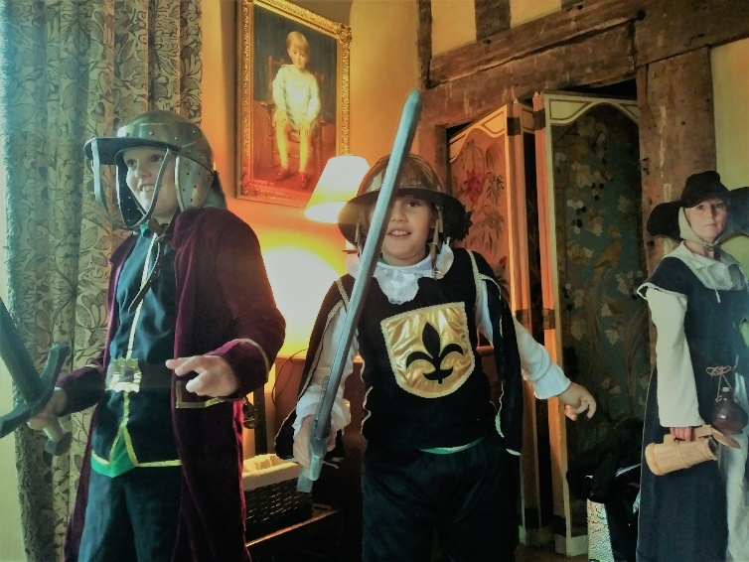
Pierrepont People

An interactive session using portraits, character cards, costumes, drama, replica armour and weapons to tell the story of the Pierrepont men who took opposing sides during the Civil War. Pupils take on these roles, and those of the rebellious and strong-minded Pierrepont women who shocked society and made history in a time when intellect and independence were not encouraged in girls.
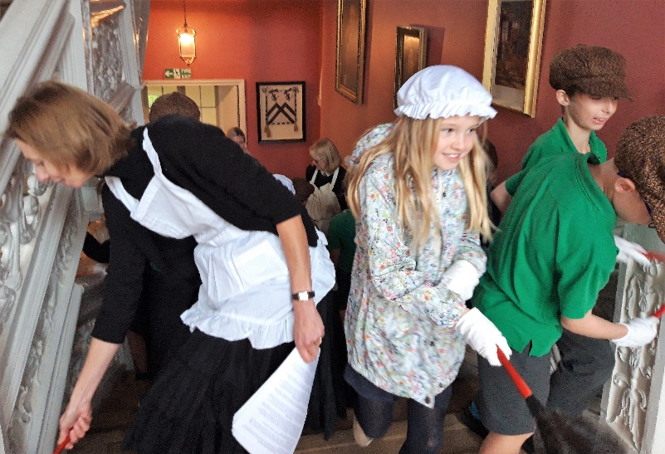
Servants Secret History Hunt

Using costume, authentic tools and materials of the 19th century, pupils take on the tasks of Victorian household servants while looking for clues to lead them to a mythical lost treasure in the house. With links to science, history and technology this activity encourages critical thinking and observational skills whilst comparing the differences in life for the noble family and the ordinary people who worked at the house.
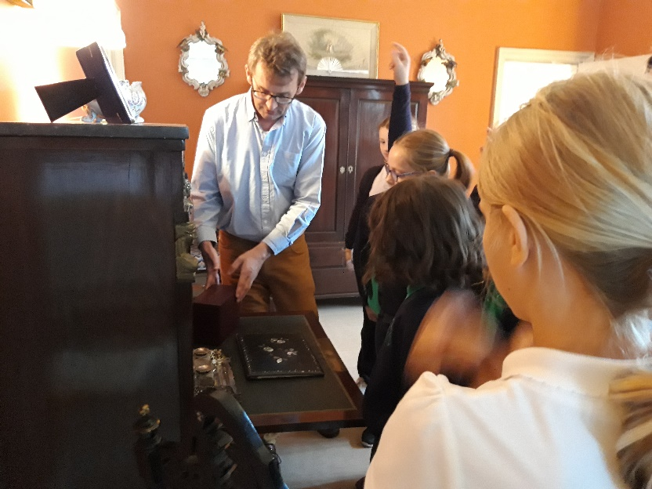

Junior House Tour

Meet Robert, direct descendent of the Pierrepont dynasty as he leads an informative and amusing tour of his home which includes authentic 16th century lodgings, Georgian reception rooms and a Victorian bedroom. With a wealth of family portraits, clothing and personal items owned by his ancestors, pupils can visualise and appreciate what life would have been like in these rooms throughout the centuries.

